Day 1 - 16th May 2025

Your Doc name:

Day 1 - 113312696- Aditya Shubham

SDLC:

Task: 1

What is SDLC?

SDLC is a structured process to design, develop, test, and deploy software. It provides a framework with defined phases to ensure efficiency, cost-effectiveness, and the delivery of a product that meets customer requirements.

5 min 10.10 to 10.15

Task 2:

Why is SDLC ?

1. Ensures Systematic & Organized Development
2. Improves Software Quality
3. Reduces Risks and Costs
4. Enhances Customer Satisfaction
5. Provides Better Project Management
6. Ensures Scalability & Maintainability
7. Compliance & Security
8. Supports Different Development Models

5 min 10.20 to 10.25

Task 3:

What are the stages of SDLC ? write 2 lines about each.

SDLC Phases

1. Planning & Requirement Analysis- Define project scope, objectives, and feasibility
2. System Design- Define architecture and specifications before coding
3. Implementation- Develop the software based on design documents
4. Testing- Identify and fix defects before deployment
5. Deployment- Release he software to users
6. Maintenance & Support- Ensure smooth operation and updates

Task 4, 5, 6

SDLC Models:

List them , description - 4 lines min and with a image

SDLC Models

1. Waterfall Model- Sequential linear approach
   1. Each stage must be completed before moving to the next.
   2. Planning & Requirements -> Design -> Implementation -> Testing -> Deployment -> Maintenance
   3. Short, well defined-projects
   4. Simple and easy to manage, good documentation
   5. No flexibility for changes, testing happens late (high risk of failure)
   6. e.g.Building a Banking System (ATM Software, transaction processing)
   7. Requirements are fixed, compliance is critical. E.g. Microsoft early Windows releases

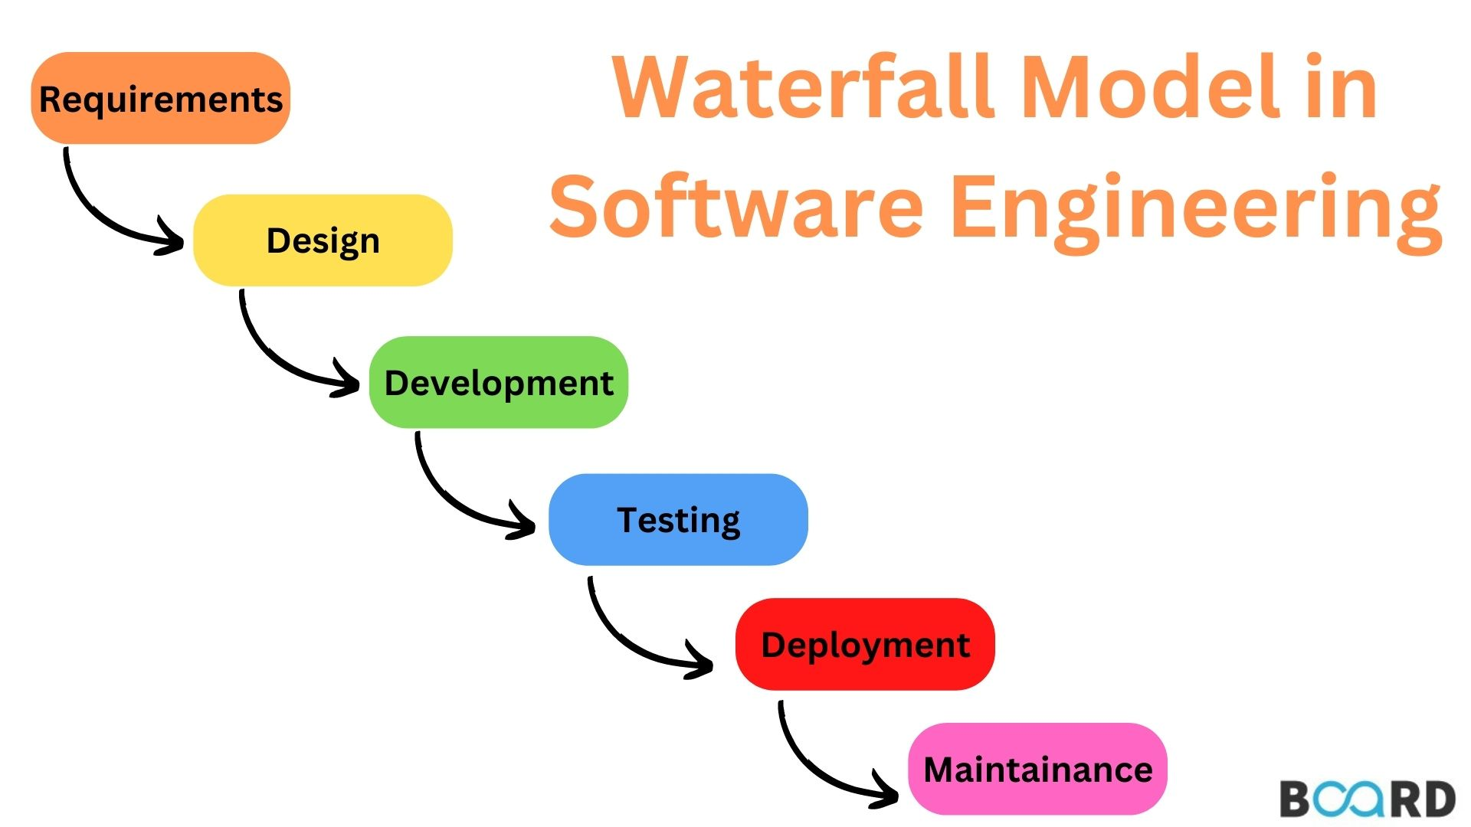

1. Agile Model- Iterative, flexible development
   1. Delivers software in small increments (usually 2-4 weeks sprints)
   2. Scrum (Sprint planning, daily standups, retrospective)
   3. Kanban (Continuous flow, visual task boards)
   4. Dynamic requirements, need for frequent customer feedbacks
   5. Adaptable to change, faster way of working software
   6. Requires high customer involvement, less predictable timeline/budget
   7. E.g. Mobile App Development, frequent updates based on user feedback
   8. Spotify uses Agile

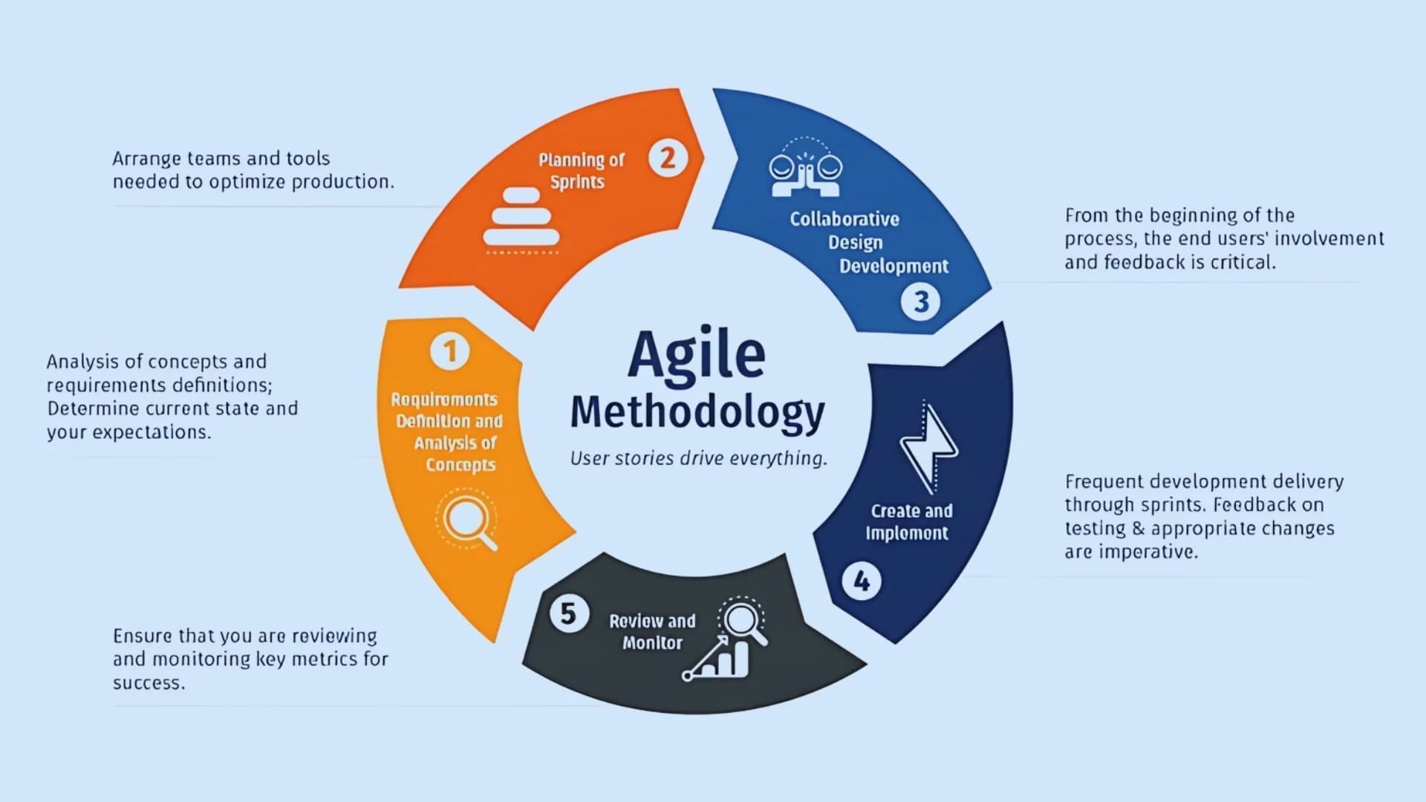

1. DevOps- Combines development and operations for continuous delivery
   1. Continuous Integration (CI) -> Continuous Development (CD) -> Monitoring
   2. Cloud-based scalable application. Frequent updates (e.g. SaaS products)
   3. Faster releases, automations reduces errors
   4. Require cultural shift in teams, high initial setup costs.

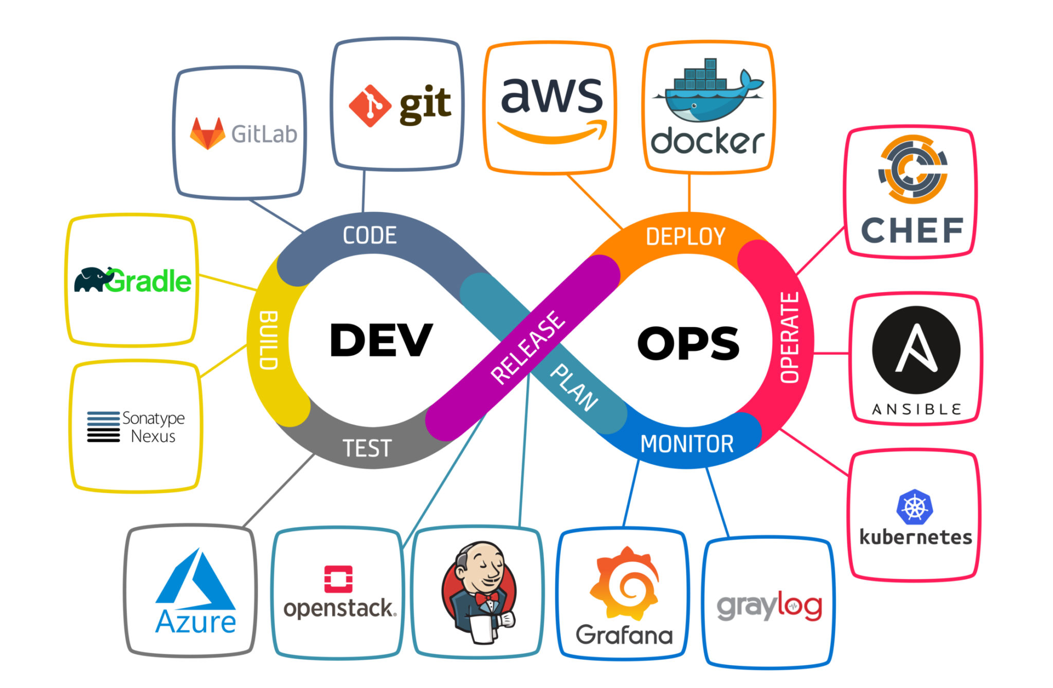

1. Spiral Model- Combines waterfall + Iterative Development
   1. Planning -> Risk analysis -> Development -> Evaluation (repeats in cycles)
   2. High-risk, complex projects, long-term projects with evolving requirements
   3. Expensive (requires frequent evaluation)

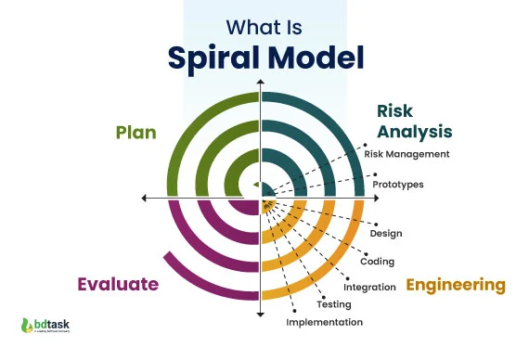

1. V-Model (Verification & Validation Model): Extension of Waterfall with testing each stage
   1. Each development phase has a corresponding testing phase.
   2. Requirements -> System testing
   3. Design-> Integration testing
   4. Coding -> Unit Testing
   5. Mission-critical systems (e.g. medical, aerospace). High-reliability requirements.
   6. Early defect detection, structured and disciplined.
   7. Rigid (hard to accommodate changes, time-consuming)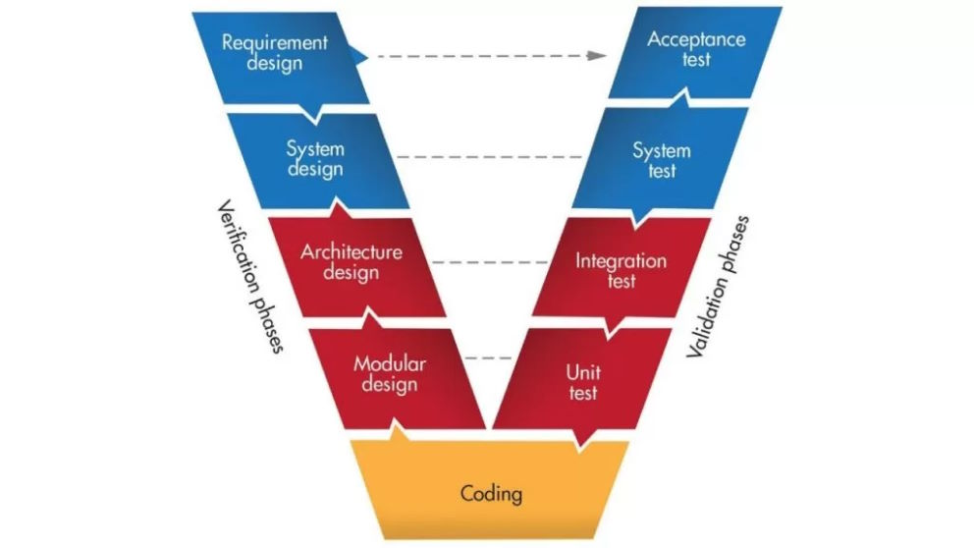
2. Iterative Model: Builds Software in Repeated Cycles
   1. Start with a simple version -> Enhance in iterations
   2. Large projects where requirements evolve. Early user feedback is needed
   3. Reduces initial delivery risk, flexible for changes
   4. Can be costly if iterations are uncontrolled

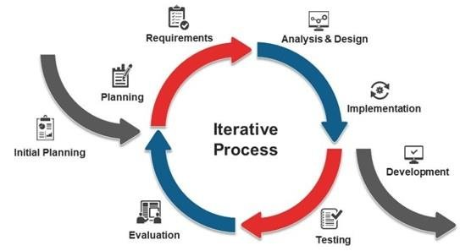

Task 7:

What is a Scrum?

Think of Scrum like a recipe for managing software projects in bite-sized chunks (called "sprints" that typically last 2-4 weeks), where a team works together like a rugby team (which is actually where the term "scrum" comes from) to get things done efficiently. Instead of trying to build everything at once, the team picks the most important tasks from a prioritized list (called a "backlog"), has quick daily check-ins (called "standups"), shows their progress to stakeholders in demo meetings (called "sprint reviews"), and then reflects on what went well or badly (in "retrospectives") - all guided by a Scrum Master who removes obstacles and helps the team stay on track, while the Product Owner makes sure they're building the right things that customers actually want. In essence, Scrum is a practical framework that helps teams deliver working software regularly while being flexible enough to handle changes, much like how a GPS recalculates your route when you take a wrong turn.

Task 8:

What is a sprint?

A short time for which all the product development process is done

Sprint are block of subtasks that are done have got its specific time limit

Task 9: Do's and Don'ts of Sprint (3 points each)

Do's:

1. Follow sprint planning and stick to committed tasks

2. Attend all sprint ceremonies (standups, reviews, retrospectives)

3. Maintain transparency and regular communication

Don'ts:

1. Change sprint scope mid-sprint or add new requirements

2. Skip important meetings or work in isolation

3. Overcommit or take more than capacity

Task 10: Stories and Backlogs in Scrum

User Stories:

- Brief descriptions of functionality from user's perspective

- Follow format: "As a [user], I want [goal] so that [benefit]"

- Should be independent, negotiable, valuable, estimable, small, and testable

Backlogs:

- Prioritized list of all required work

- Contains user stories, bugs, technical tasks

- Dynamic and regularly refined

- Owned by Product Owner

- Constantly evolving based on business needs

Task 11: Scrum Artifacts

1. Product Backlog:

- Complete list of all desired product features

- Prioritized by Product Owner

- Dynamic and continuously updated

- Contains epics, stories, bugs, technical debt

2. Sprint Backlog:

- Subset of Product Backlog items selected for current sprint

- Detailed plan for delivering increment

- Owned by Development Team

- Updated daily during sprint

3. Burn-Down Chart:

- Visual representation of work remaining vs time

- Shows sprint progress

- Updated daily

- Helps identify if team is on track

4. Increment:

- Sum of all completed Product Backlog items

- Must be "Done" as per Definition of Done

- Should be potentially releasable

- Represents value delivered to stakeholders

Task 12: Ports and Protocols

PORTS:

- Virtual endpoints for network communications

- Numbers ranging from 0 to 65535

- Divided into categories:

* Well-known ports (0-1023)

* Registered ports (1024-49151)

* Dynamic ports (49152-65535)

Common Well-Known Ports:

1. HTTP: Port 80

2. HTTPS: Port 443

3. FTP: Port 21

4. SSH: Port 22

5. SMTP: Port 25

6. DNS: Port 53

7. Telnet: Port 23

PROTOCOLS:

1. TCP (Transmission Control Protocol)

- Connection-oriented

- Reliable data delivery

- Used for: Email, web browsing, file transfer

2. UDP (User Datagram Protocol)

- Connectionless

- Faster but less reliable

- Used for: Streaming, gaming, DNS

3. HTTP/HTTPS

- Web communication

- HTTPS is secure version with encryption

4. FTP (File Transfer Protocol)

- File transfer between client and server

5. SSH (Secure Shell)

- Secure remote access

- Encrypted communications

6. SMTP (Simple Mail Transfer Protocol)

- Email transmission

7. DNS (Domain Name System)

- Domain name resolution to IP addresses

Remember: Port + Protocol combinations enable specific types of network communications and services.

Task 13: Different Network Types

1. PAN (Personal Area Network)

- Smallest network type

- Range: Few meters

- Examples: Bluetooth devices, wireless headphones

- Used for personal device connections

2. LAN (Local Area Network)

- Limited geographical area (building/campus)

- High data transfer speeds

- Common in offices, schools, homes

- Usually connected via Ethernet or Wi-Fi

3. MAN (Metropolitan Area Network)

- Covers a city or large campus

- Larger than LAN, smaller than WAN

- Examples: Cable TV networks, city-wide networks

- Connects multiple LANs

4. WAN (Wide Area Network)

- Spans large geographical areas

- Connects multiple LANs/MANs

- Example: Internet

- Uses telecommunication lines

5. WLAN (Wireless Local Area Network)

- Wireless version of LAN

- Uses Wi-Fi technology

- No physical cable connections

- Common in homes and offices

6. CAN (Campus Area Network)

- University/corporate campus networks

- Connects multiple buildings

- Combination of various network types

7. SAN (Storage Area Network)

- Dedicated network for storage devices

- High-speed data transfer

- Used in data centers

- Specialized for data storage/backup

8. VPN (Virtual Private Network)

- Creates secure connection over public network

- Encrypts data transmission

- Provides remote access

- Ensures privacy and security

Each network type serves specific purposes and has distinct characteristics in terms of:

- Geographic scope

- Speed

- Security

- Purpose

- Infrastructure requirements

Task 14: Types of Servers

1. Web Server

- Hosts websites and web applications

- Handles HTTP/HTTPS requests (Apache, Nginx)

- Delivers web content to browsers

2. Database Server

- Stores and manages databases

- Handles data queries and updates

- Examples: MySQL, PostgreSQL, MongoDB

3. File Server

- Centralizes file storage and sharing

- Manages access permissions

- Common in corporate environments

4. Mail Server

- Handles email sending/receiving

- Manages email accounts and routing

- Examples: Microsoft Exchange, Postfix

5. Application Server

- Hosts applications and business logic

- Connects web and database servers

- Examples: Tomcat, JBoss, WebLogic

6. DNS Server

- Resolves domain names to IP addresses

- Maintains DNS records

- Critical for internet navigation

7. Proxy Server

- Acts as intermediary between users and internet

- Provides caching and filtering

- Enhances security and performance

8. FTP Server

- Manages file transfers

- Provides file upload/download services

- Controls file access permissions

Task 15: DNS (Domain Name System)

1. Purpose:

- Translates domain names to IP addresses

- Makes internet navigation user-friendly

- Works like a phone book for the internet

2. DNS Hierarchy:

- Root Domain (.)

- Top-Level Domains (com, org, net)

- Second-Level Domains (google, amazon)

- Subdomains (mail, www)

3. Key Components:

- DNS Servers

- DNS Records (A, MX, CNAME, etc.)

- DNS Cache

- DNS Resolvers

4. DNS Resolution Process:

- User enters domain name

- Local DNS cache check

- Query to DNS resolver

- Recursive search through DNS hierarchy

- Returns IP address to user

5. Common DNS Record Types:

- A Record (IPv4 address)

- AAAA Record (IPv6 address)

- MX Record (mail servers)

- CNAME (aliases)

- NS Record (nameservers)

Task 16:

What are the different Network Topologies?

Network Topology is the physical or logical arrangement of network devices and their interconnections in a computer network. It defines how different nodes (computers, servers, switches, etc.) are connected and how they communicate with each other.

Types include Bus, Star, Ring, Mesh, Tree, Hybrid, and Point-to-Point, each having unique characteristics and use cases suitable for different network requirements.

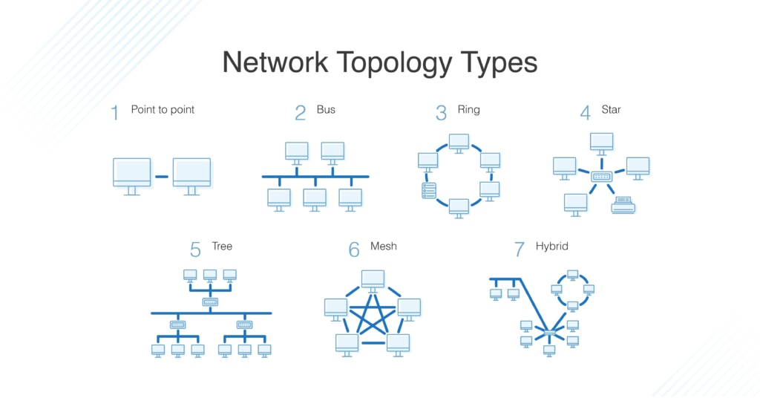

What is OSI Model?

Describe the 7 layers with description.

OSI Model: A conceptual framework that standardizes the functions of a telecommunication/computing system into seven abstraction layers for network communication.

The 7 Layers (Top to Bottom):

7. Application Layer

- Directly interacts with user applications

- Examples: HTTP, FTP, SMTP, DNS

6. Presentation Layer

- Data formatting and encryption

- Handles data translation and encryption

5. Session Layer

- Manages connections between applications

- Controls authentication and session restoration

4. Transport Layer

- End-to-end delivery and error checking

- TCP/UDP protocols operate here

3. Network Layer

- Routes data packets between networks

- IP addressing and path determination

2. Data Link Layer

- Node-to-node delivery and error detection

- MAC addressing and frame synchronization

1. Physical Layer

- Raw bit transmission over physical medium

- Handles cables, switches, and physical topology

Task 17:

What is OSI Model?

Describe the 7 layers with description.

The OSI (Open Systems Interconnection) Model is a conceptual framework that standardizes the functions of a telecommunication or computing system into seven distinct layers. Here are the seven layers from top to bottom:

7. Application Layer

- Direct interaction with end-user applications

- Provides protocols for software applications

- Examples: HTTP, FTP, SMTP, DNS, Telnet

- Functions: File transfers, email, web browsing

- Units: Data

6. Presentation Layer

- Data formatting and encryption

- Handles data translation, compression, and encryption

- Ensures data is readable by receiving system

- Examples: JPEG, MPEG, SSL/TLS

- Units: Data

5. Session Layer

- Manages sessions between applications

- Establishes, maintains, and terminates connections

- Handles authentication and authorization

- Examples: NetBIOS, RPC

- Units: Data

4. Transport Layer

- End-to-end communication control

- Ensures reliable data delivery

- Flow control and error checking

- Examples: TCP, UDP

- Units: Segments (TCP) / Datagrams (UDP)

3. Network Layer

- Logical addressing and routing

- Determines best path for data delivery

- Handles packet forwarding

- Examples: IP, ICMP, OSPF

- Units: Packets

2. Data Link Layer

- Physical addressing

- Error detection and correction

- Flow control between adjacent nodes

- Examples: Ethernet, PPP, Switch, Bridge

- Units: Frames

1. Physical Layer

- Raw bit transmission

- Hardware specifications

- Physical network elements

- Examples: Cables, hubs, repeaters

- Units: Bits

Key Points:

1. Data flows down the stack on the sending side and up the stack on the receiving side

2. Each layer provides services to the layer above and receives services from the layer below

3. Each layer adds its own header information (encapsulation) when sending data

4. Each layer removes header information (de-encapsulation) when receiving data

5. Layers 1-4 are media-focused layers

6. Layers 5-7 are application-focused layers

The OSI Model helps in:

- Understanding network architecture

- Troubleshooting network problems

- Standardizing network components and protocols

- Teaching network concepts

- Developing new network technologies

Mnemonic to remember the layers (top to bottom):

"All People Seem To Need Data Processing"

or

"Please Do Not Throw Sausage Pizza Away"

(Physical, Data Link, Network, Transport, Session, Presentation, Application)

**Add ons-**

**7. What is Software Configuration Management, and how does it work?**

The process of tracking and regulating changes that occur during the software development lifecycle is known as software configuration management. Any modification made during the development of software must be tracked using a well-defined and controlled process. Any modifications performed during software development are regulated through a well-defined process, thanks to configuration management. Revision control and the establishment of baselines are two SCM procedures.

**8. What do a Software Project Manager's responsibilities entail?**

The Software Project Manager is in charge of seeing the project through to completion. The Software Project Manager is responsible for ensuring that the entire team follows a methodical and well-defined approach to software development. They also handle project planning, tracking project status, resource management, and risk management.

**9. What do you know about Scrum impediments?**

Obstacles or challenges that the scrum team faces slow down their work speed are referred to as impediments. An obstacle is anything that tries to prevent the scrum team from getting work "Done." Impediments can take many different forms. Some of the roadblocks include resource shortages or sick team members, technical, operational, and organisational issues, a lack of management support systems, and business issues.

**10. Briefly explain Scrum methodology in the Agile model.**

Scrum is an agile development approach based on iterative and incremental procedures that are used in the creation of software. It's an agile structure that's adaptable, rapid, flexible, and excellent at delivering value to customers throughout the project's development. Companies of all sizes employ the Agile Scrum technique because of its ability to provide high-end cooperation and efficiency for project-based work. Scrum is a sort of agile approach that breaks projects down into manageable parts known as "sprints." The Agile Scrum methodology is ideal for companies who need to complete projects fast.

**11. What are Capability Maturity Model(CMM) levels?**

Following are the five Capability Maturity Model Levels:

* Initial: The first step is to create an unstable process environment. The software development process is considered haphazard and even chaotic at times. There are few methods that have been specified, and success is based on individual effort and heroism.
* Repeatable: Work is planned and monitored, making it repeatable. To track cost, schedule, and functionality, basic project management techniques are implemented.
* Defined: This level encompasses written and defined standards that evolve over time and support consistent performance. The work is well defined at this point.
* Managed: Extensive data on the software development process and product quality are gathered. Both the software development process and the end products are quantified and managed.
* Optimized: Work is based on continuous improvement (optimization). The focus on continuously improving process performance is a significant feature of this level.

**12. What is Capability Maturity Model?**

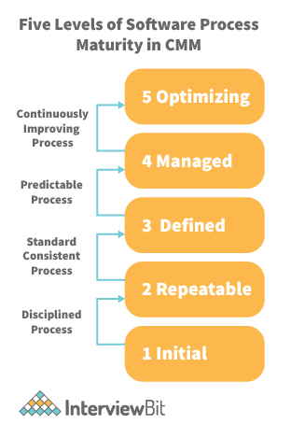

The Capability Maturity Model (CMM) is a cross-discipline and technical paradigm for facilitating and refining software development processes and system improvement. This methodology is at the heart of most management systems that aim to improve the quality of all product and service development and delivery.

**13. What is Level-0 DFD?**

Context Diagram is another name for DFD Level 0. It's a high-level overview of the entire system or process that's being studied or modelled. It's meant to be a quick peek into the system, displaying it as a single high-level process with its connections to external entities. Stakeholders, business analysts, data analysts, and developers should all be able to understand it readily.

**14. How can DDLC and SDLC work together?**

The DDLC (Documentation Development Life Cycle) is a software documentation development life cycle used by technical documenters to prepare software documentation. The life cycle is followed in tandem with the SDLC, as testers and developers work on the programme at the same time. Because the documentation requires input and feedback from the various phases of the SDLC, the DDLC has stages that are comparable to the SDLC.

**15. What are different types of prototype model?**

There are four types of Prototyping models:

* Rapid Throwaway prototypes.
* Evolutionary prototype.
* Incremental prototype.
* Extreme prototype.

**16. What is FRS document?**

This document captures the user's voice from the outside, or the end user's perspective. A Business System Analyst creates it (BSA). This paper demonstrates how a system will react when a user interacts with it in order to meet the BRD and SRD standards. The key area of interest for software experts is the Functional Requirement Specification (FRS). An FRS is useful for software testers to learn the situations in which the product is intended to be tested, just as it is for developers to understand what product they are planning to produce. An FRS's ultimate purpose is to meet all of the requirements outlined in the SRS and BRS regulations.

**17. What is the Software release process?**

The Software Development Life Cycle (SDLC) release phase is historically connected with production, deployment, and post-production operations, which generally include software maintenance and support. So, release management is the process of managing, planning, scheduling, and controlling a full software development at every stage and environment, including testing and releasing software releases.

**18. What is the use of JAD session?**

JAD is a strategy for defining business system requirements that are commonly utilised in the early phases of a systems development project. JAD's goal is to bring MIS and end-users together in a structured workshop setting in order to extract outcome system needs. It allows clients and developers to swiftly agree on a project's fundamental scope, objectives, and specifications

**SDLC MCQ**

1.

A feasibility study using the SDLC model is conducted to

determine whether or not the project is technically possible

determine whether the proposal is financially viable

Both a and b

None of the above

2.

A well-documented life cycle model aids in the detection of what during the development phase?

Inconsistencies

Redundancies

Omission

All of the above

3.

How many lines of code does the Build & Fix Model suit for programming exercises?

100-200

300-400

600-700

Above 800+

4.

In which life cycle does regression testing play a significant role?

Waterfall model

V model

Iterative model

All of the above

5.

What determines if the project should go forward?

feasibility assessment

opportunity identification

system evaluation

program specification

6.

What is the most significant disadvantage of employing the RAD Model?

Developers/designers that are highly specialized and skilled are required.

Component reusability is improved.

Encourages client/customer input.

Increases component reusability.

7.

Which of the following developmental models is incremental?

Prototyping, V model, Agile

Prototyping, RAD, Agile, RUP

Prototyping, V model, RAD, Agile, RUP

All of the above

8.

Which of the following is an Agile development characteristic?

Shared code ownership

Test-Driven Development

Implement the simplest solution to meet today's problem

Continual feedback from customer

All of the above

9.

Which of the following steps in the SDLC framework are valid?

Requirement Gathering

Software Design

System Analysis

All of the above

10.

Who is in charge of system development, staffing, budgeting, and reporting, as well as ensuring that deadlines are met?

Project managers

Network engineers

Graphic designers

Systems analysts